

**JAVA IOT DEVELOPER**

**LAB - 5**

**SUBMITTED BY: SUBMITTED TO:**

Ayush Kumar Jha CHANDAN SHARMA SIR

500086400

B.C.A (IOT)

(2020-2023)

**DEVICE CLASS:**

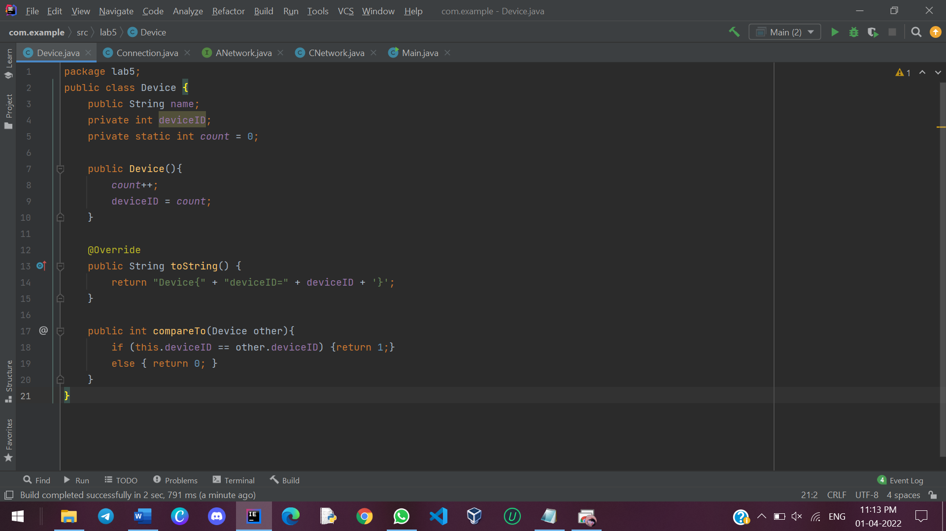

**CONNECTION CLASS:**

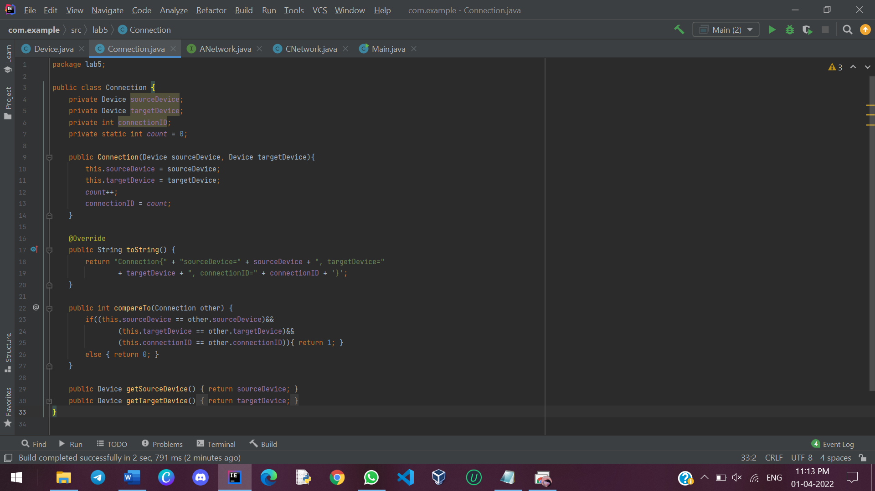

**ANetwork INTERFACE:**

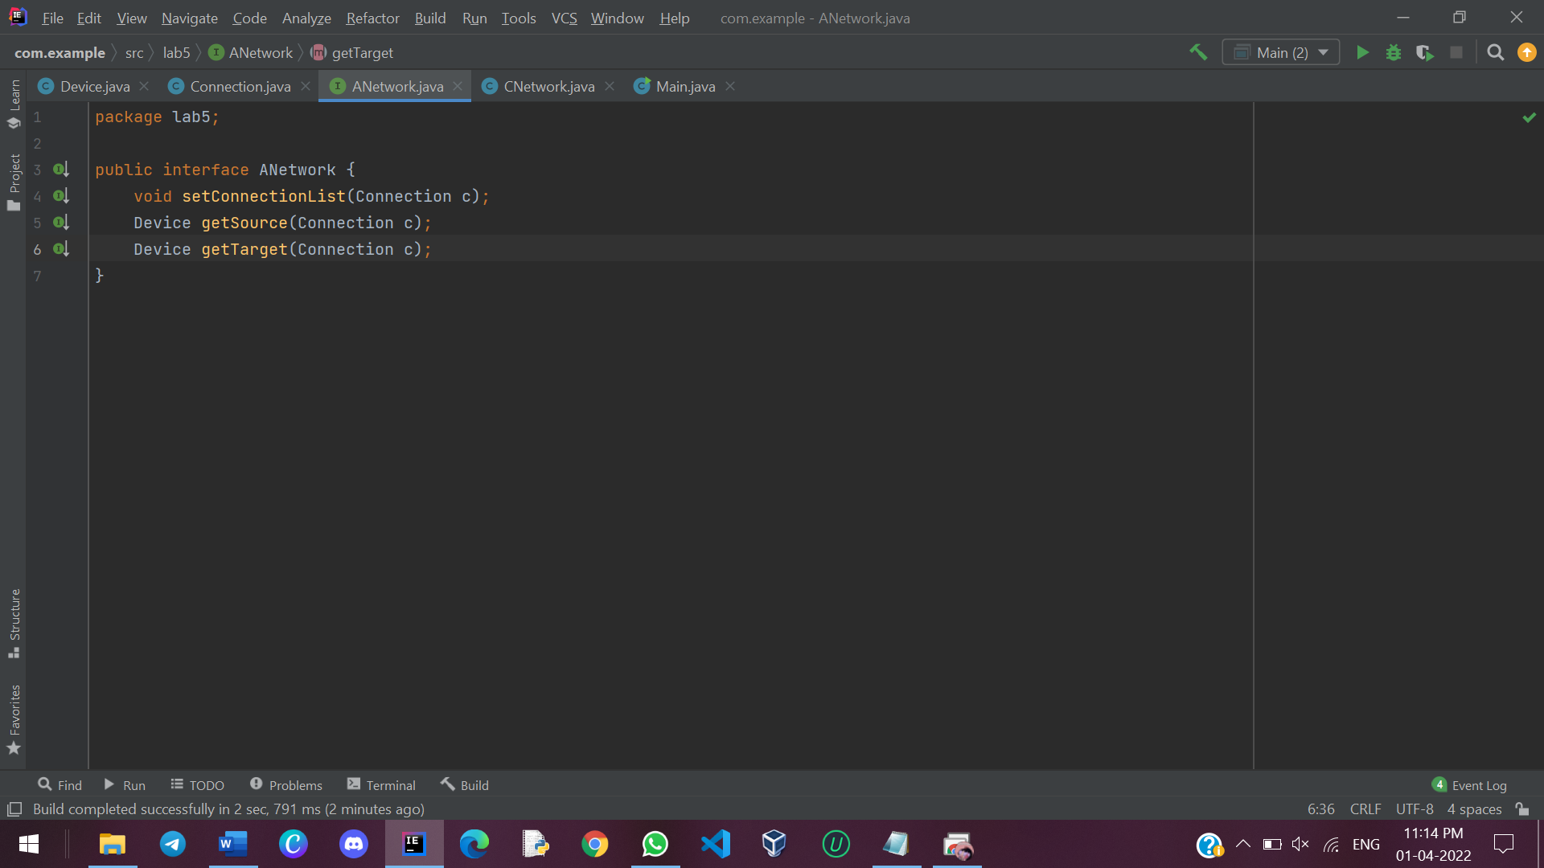

**CNetwork CLASS:**

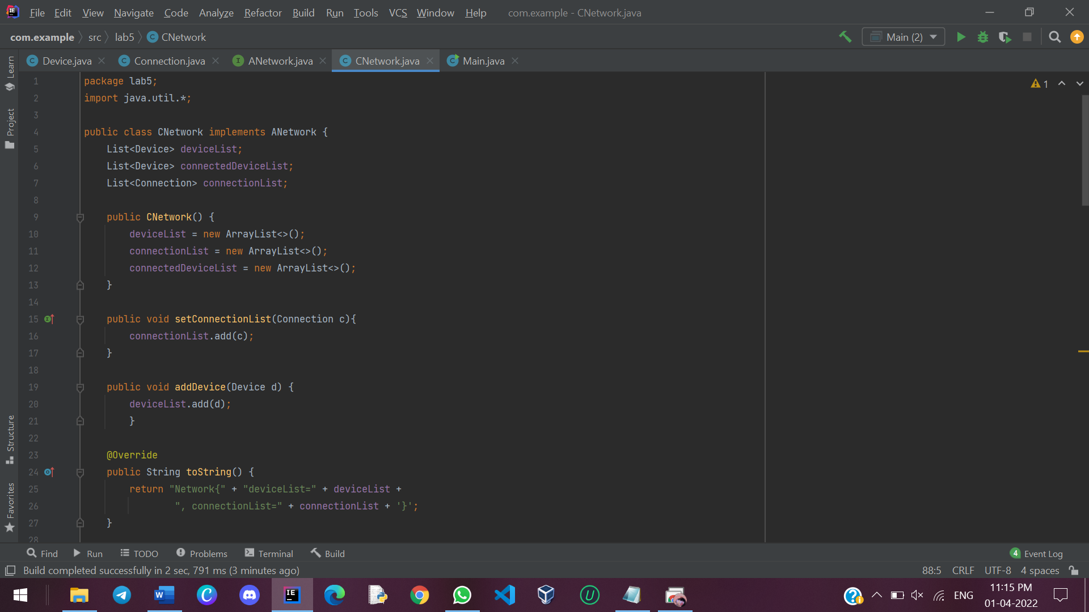

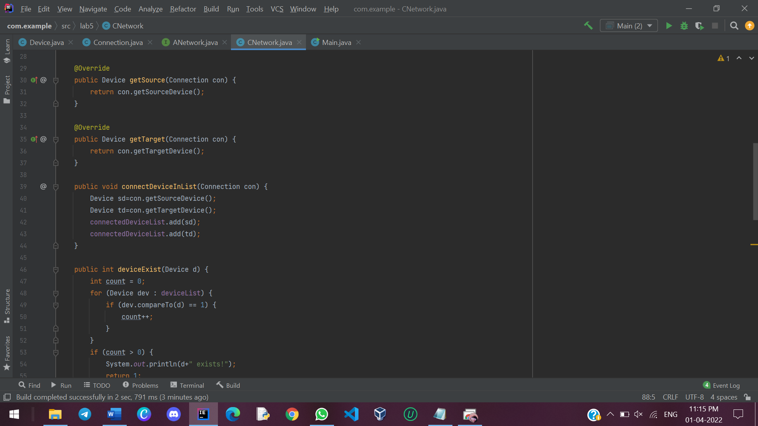

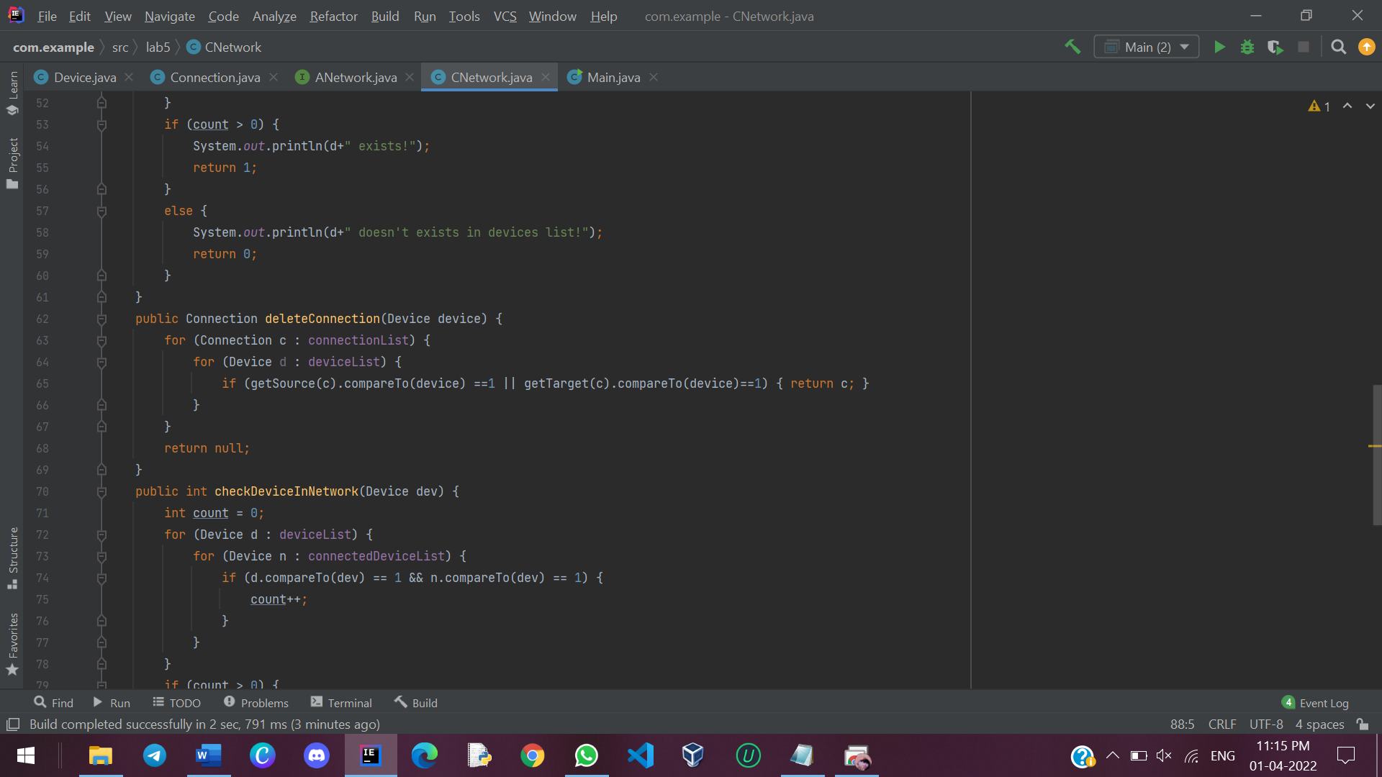

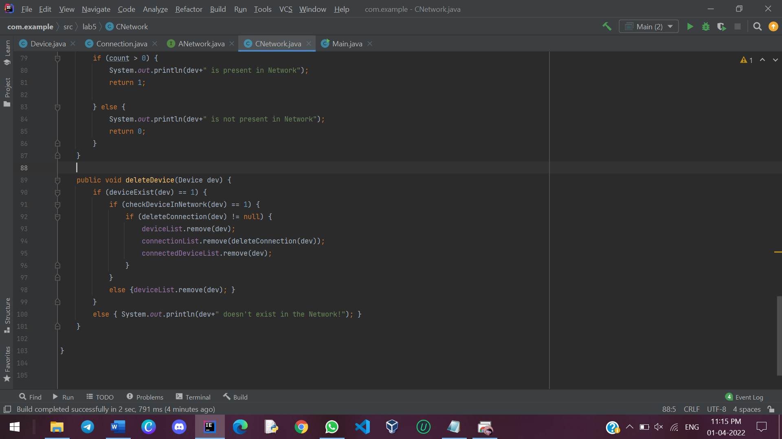

**MAIN CLASS:**

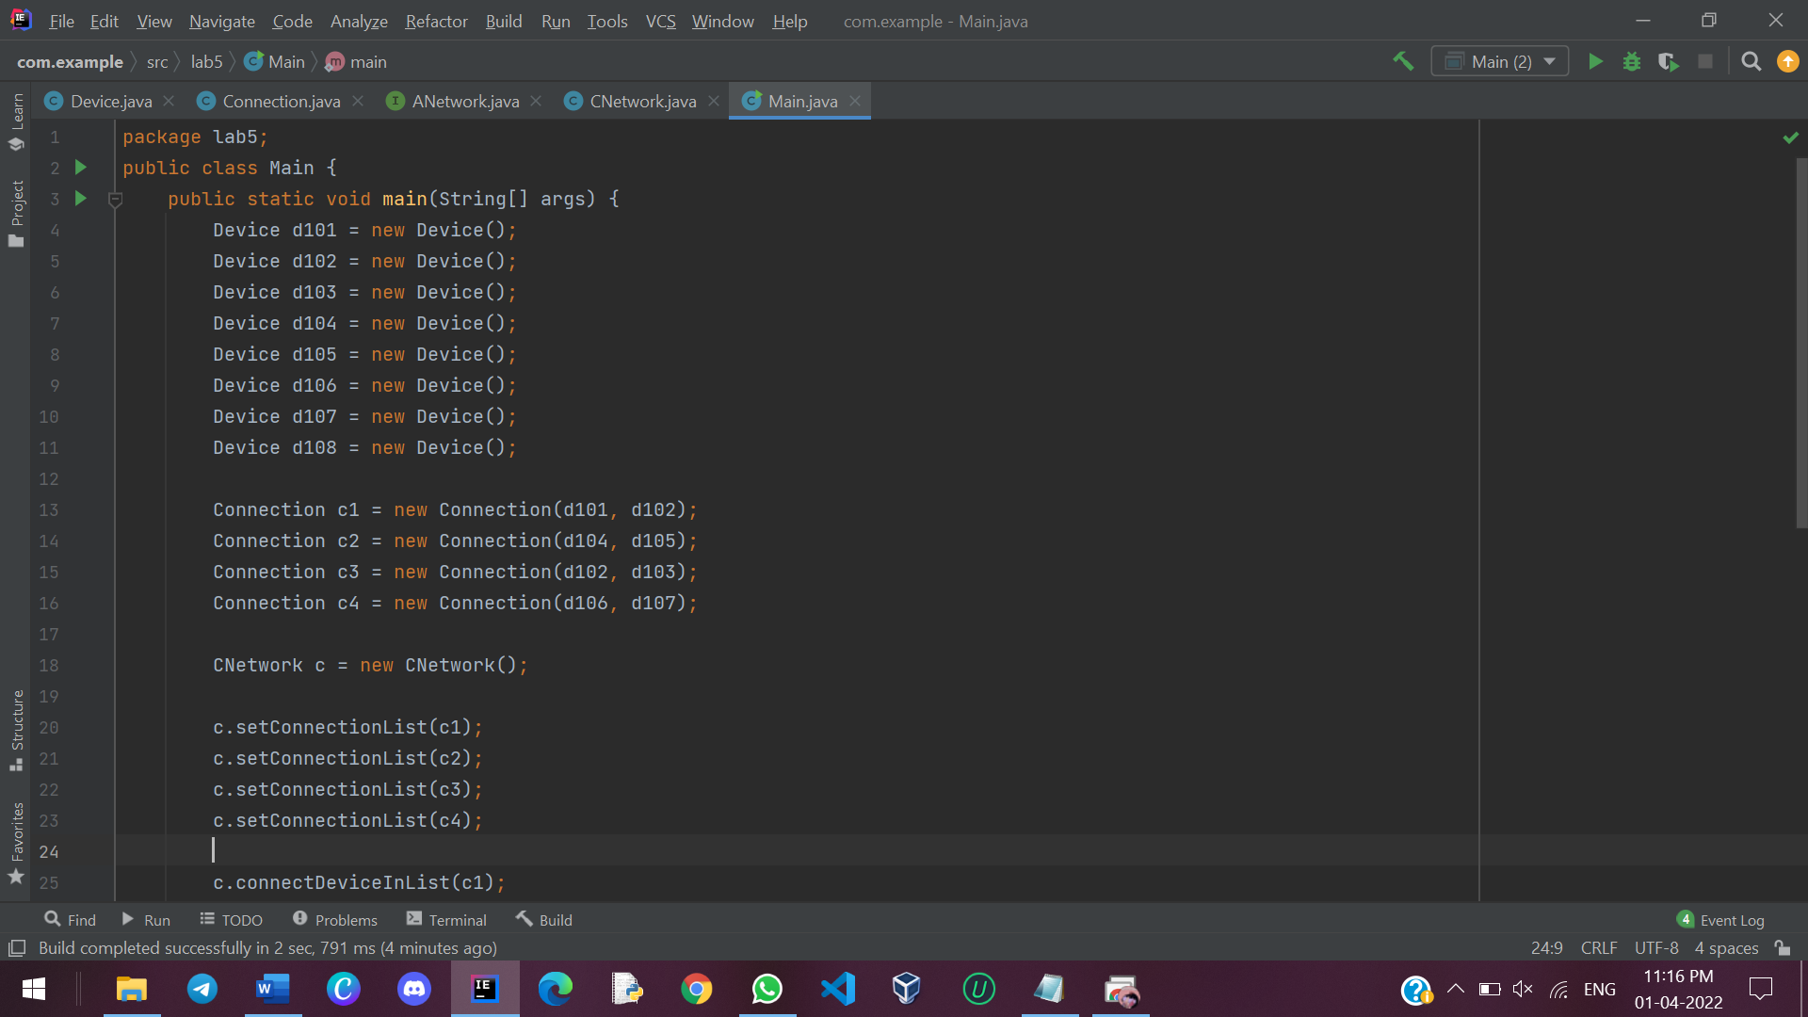

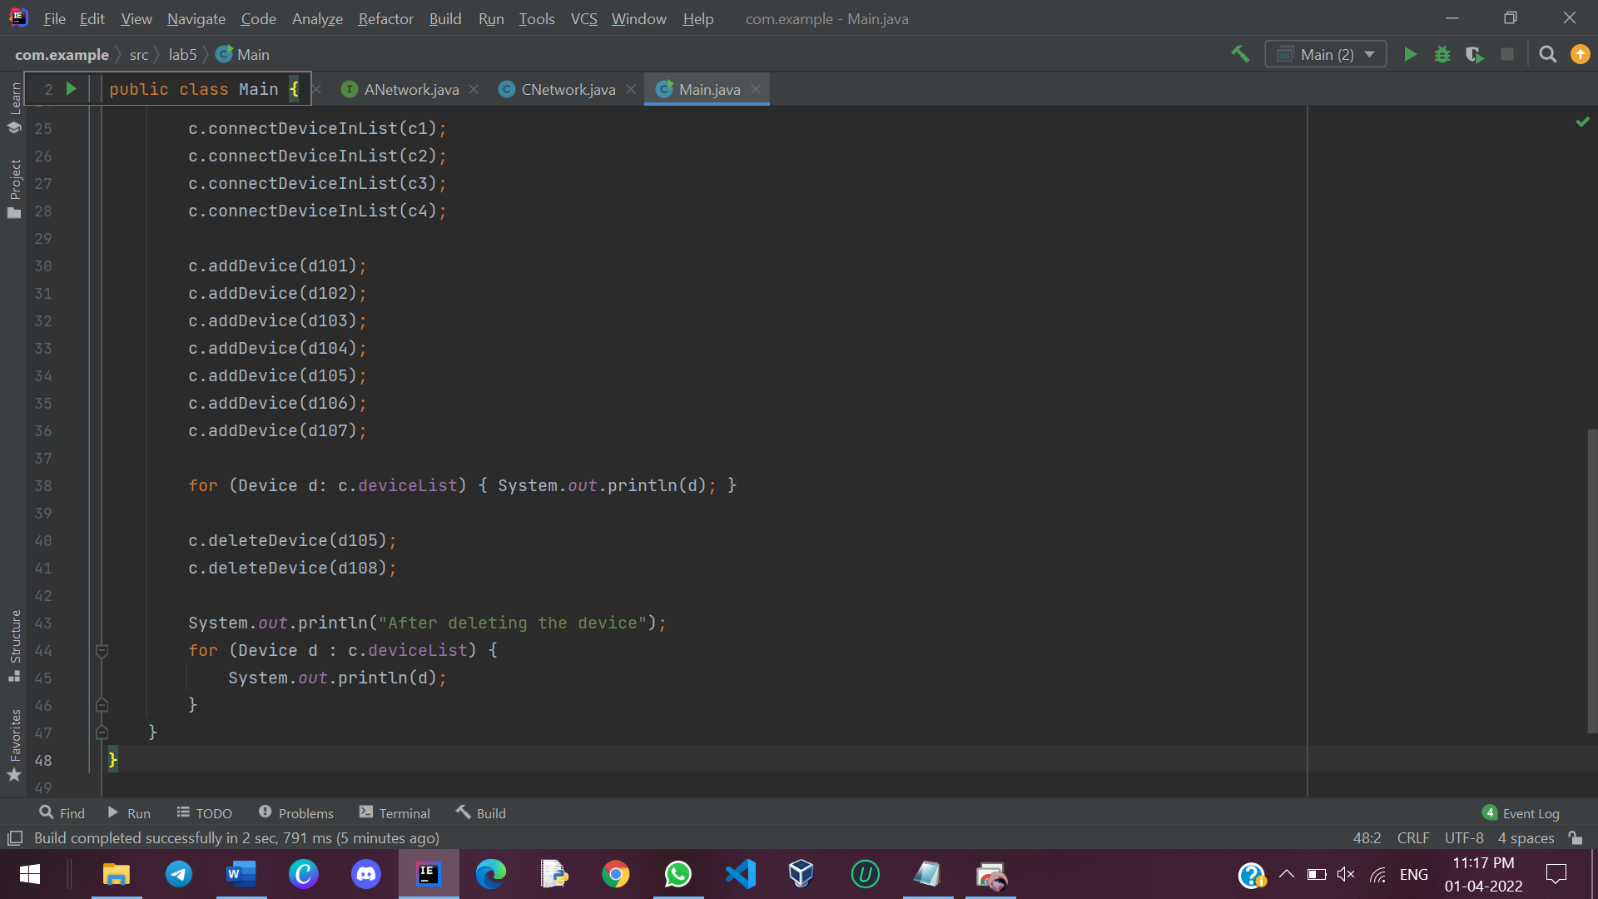

**OUTPUT:**

